Brazil has some of the highest quality hospitals in Latin America. Unlike other countries, Brazil has a public health care system that provides services to its entire population. Theoretically, the public health care system works very well; however, the reality is that public hospitals don’t have enough beds and inpatients are found lying on the bare floor of the corridors. Access to medication and the number of doctors are far from being enough. (Novais, 2012)
The medical equipment proposed is the Rx Assistant. This device would become a physician’s right-hand man. They would be able to perform a full-body scan of a patient within minutes. The information would be updated in the patient’s medical records immediately. If there was a heart blockage, it could be assessed on a routine office visit. We can improve patient care while reducing the time required.
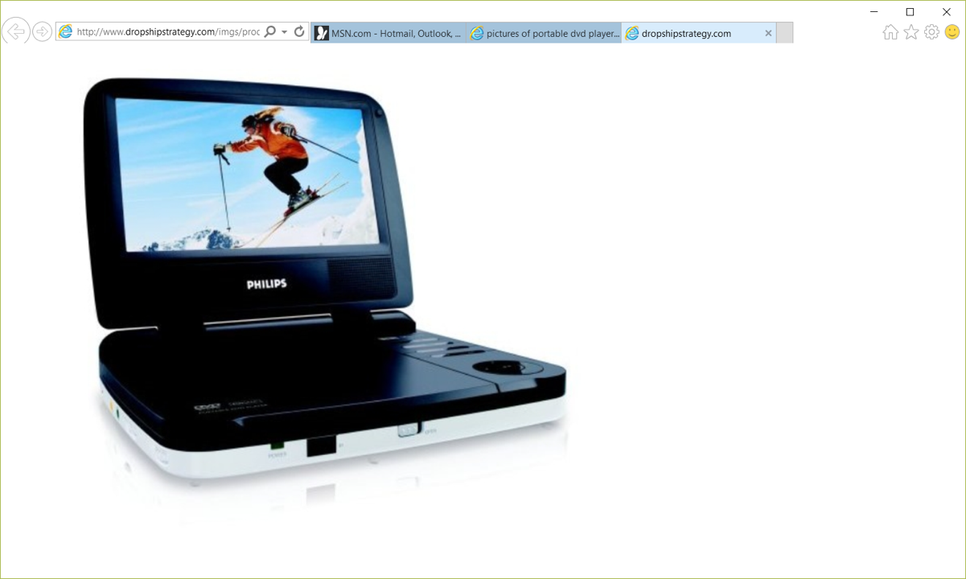
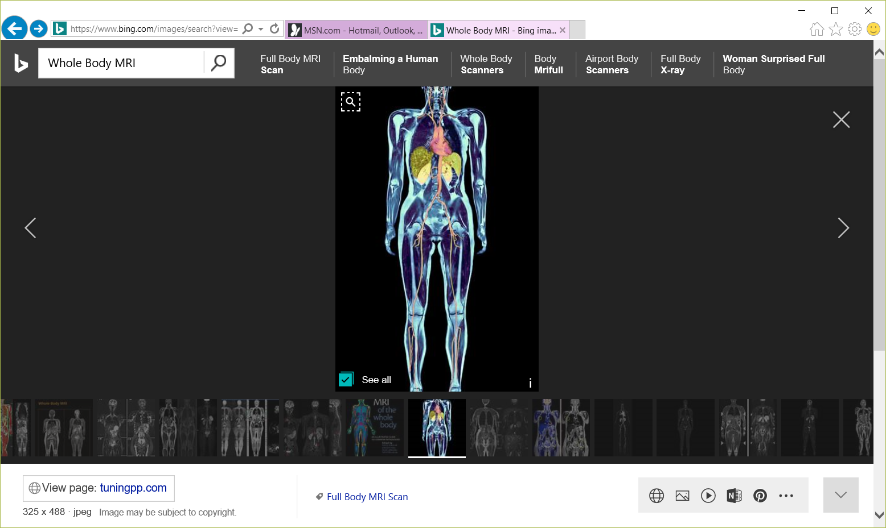
Interactive Touch Screen
Diagnostic Pad

The current major competitors in the medical equipment field are Philips Medical Systems Ltda, Skytron LLC, and FUJI, all manufacturing medical equipment in Brazil. (Novais, 2012)
The main products exported for the North Americans are mineral fuel, oil, iron, steel, machinery and beverages. The top import categories were machinery, mineral fuel, aircraft, electrical machinery and optic and medical instruments. (Farah, 2017) An important competitive advantage that we would have with proposing this product is that we have the advantage of having a lean structure. We also have the advantage of being much closer to the customer than the major companies and we can be very flexible. As they already import medical instruments from the U.S. there would already be an established base for the business.

References
DeCarlo, S. (2016, July 22). Fortune 500. Retrieved from The Fortune 2016 Global 500 : http://fortune.com/global500/list/filtered?hqcountry=Brazil
Farah, A. G. (2017, July 9). The Brazil Business. Retrieved from thebrazilbusiness.com: http://thebrazilbusiness.com/article/largest-trading-partners-of-brazil
Novais, A. (2012, May 14). Health care in Brazil. Retrieved from The Brazil Business: http://thebrazilbusiness.com/article/healthcare-in-brazil

